Simulator of Distance Vector Routing

Alexander Gonzalez

page1image83472000

**Introduction:**

This project simulates distance vector routing for a given network. The main goal of this project is to study the impact of different factors on the convergence times to optimal routes.

With this simulator, you may input any .txt file as an argument and the simulator will provide the initial routing tables for each node, the final routing tables for each node, the number of rounds it took to complete each nodes routing table, the ID of the last node converged and the path used by data packets to get to its destination.

**Design:**

Three structs were used:

1. rTable
2. dvPacket
3. Node

rTable is used to store variables that contain the destination, cost, and next hop for each node.

dvPacket has a variable named src, which stores where the DV packet came from, and destination, which stores where the DV packet is being sent to. dvPacket also contains a vector of rTables called compare, which is a copy of the routing table from the source node which will be compared to the destination node’s routing table.

Node has a variable called name, and two vectors, one of rTables called rT, which stores the nodes routing table, and another called neighbors which stores ints, which are the names of the node’s direct neighbors.

I decided to use vectors instead of an array because I didn’t want to put a cap on how many nodes a topology file could have. Because of this, I had to use many nested for loops, as you will see. However they are pretty easy to follow and won’t give you much of a headache when looking at the code.

**Build/Run Instructions:**

To build this simulator, you will need access to a Linux command line. Use the cd command to get into the Computer_Networks_Project_1 folder. Use the line below to compile the simulator.

g++ main.cpp -o sim

And use this line to run the simulator:

./sim topology#.txt (topology1-3.txt is provided in the folder)

Be sure to include the .txt file in the Computer_Networks_Project_1 folder or the program will not find the file to read.

The topology1-3.txt files will be included in the folder as sample tests.

Also be sure to include the .txt file as an argument before you run the simulator or the file will not be found.

**Example of How to Compile and Run:**

1. Use the command cd to enter the Computer_Networks_Project_1 folder

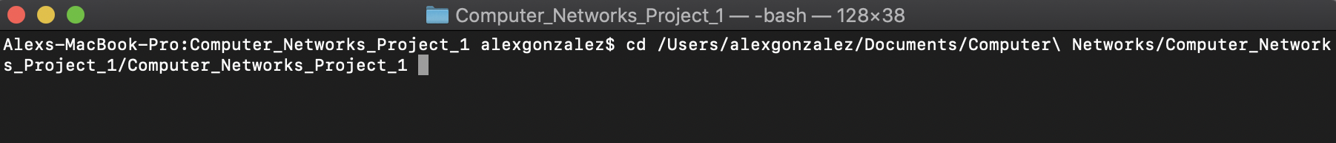

1. Compile and Run the simulator. Be sure to include the .txt file as the argument or the simulator will not be able to find the file.

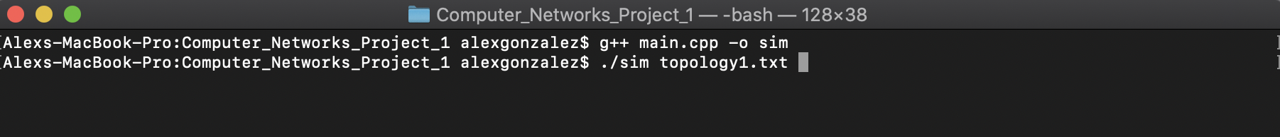

1. Enter file name you would like the Simulator to read. This will give you the initial routing table for each node, the final routing table for each node, the last node to converge, the total number of DV packets sent, and the number of rounds to achieve convergence. If you want to use the packet path feature, type “Y” when prompted to get an in-depth look at the path a packet takes to reach its destination.

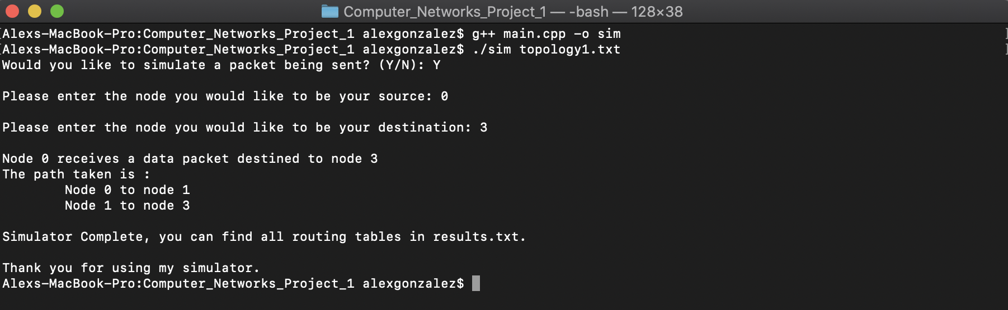

1. If the file is not found, you will be given an error message saying that the topology file is missing, so make sure the file you want read is included in the Computer_Networks_Project_1 folder. (Three tests will be provided – topology1-3.txt). 
2. Here is a screenshot of a result.txt file created by the simulator.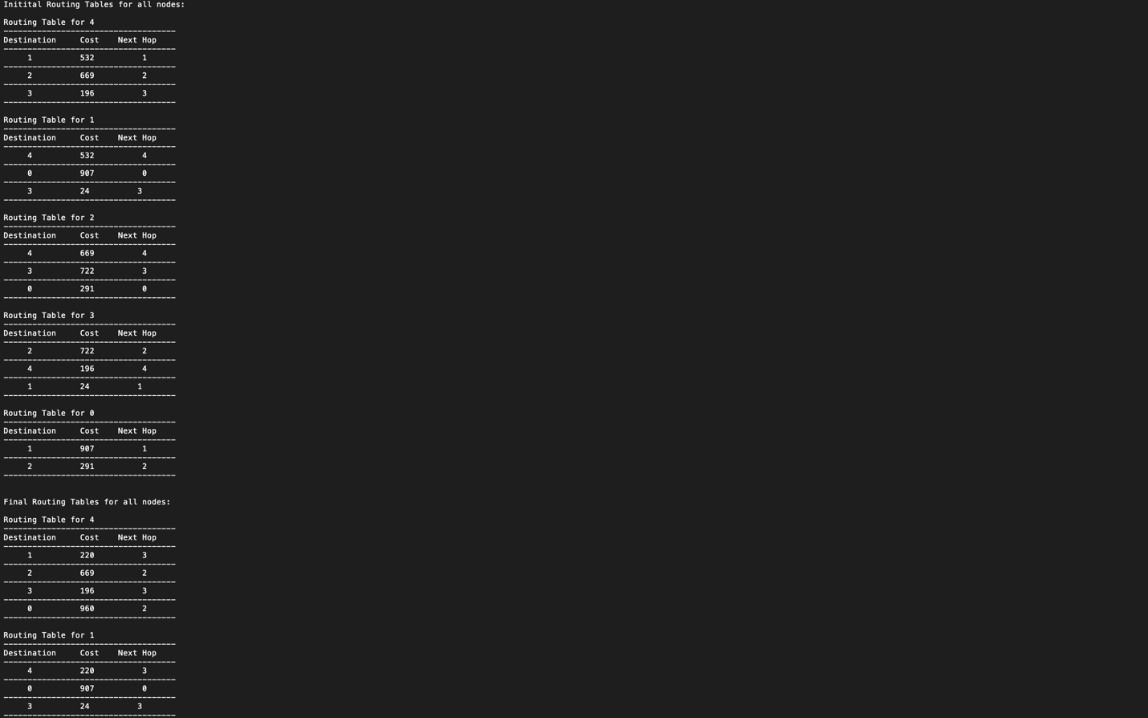

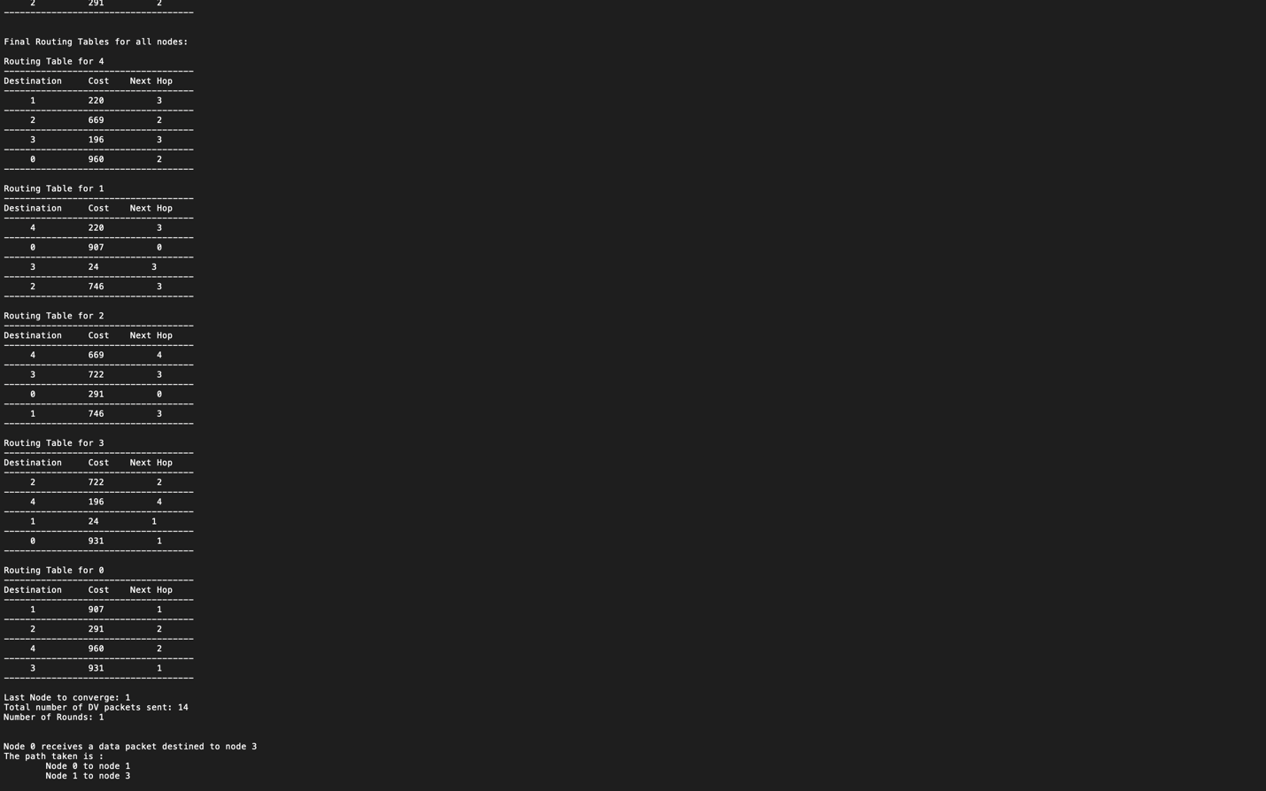

**Final Notes:**

* Continuous runs of the simulator will overwrite the results.txt file created, so be sure you do not need the results from a specific run as they will be erased. Because of this, I included the path a packet takes for each topology for easy grading.
  + Topology 1 (Node 0 to Node 3): 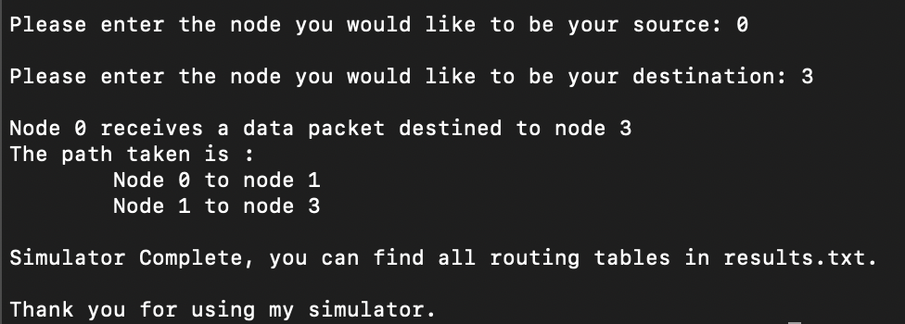
  + Topology 2 (Node 0 to Node 7):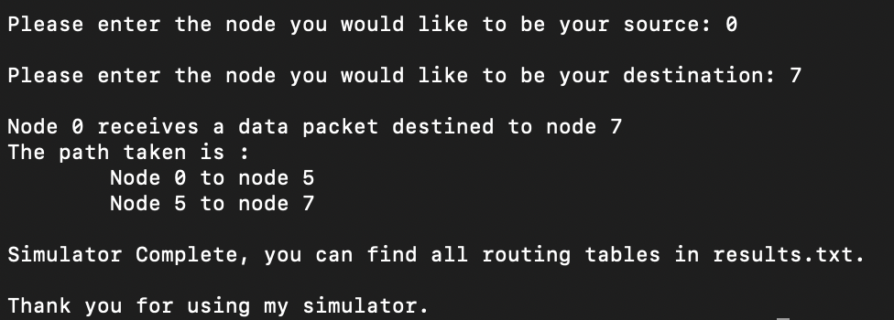
  + Topology 3 (Node 0 to Node 23):